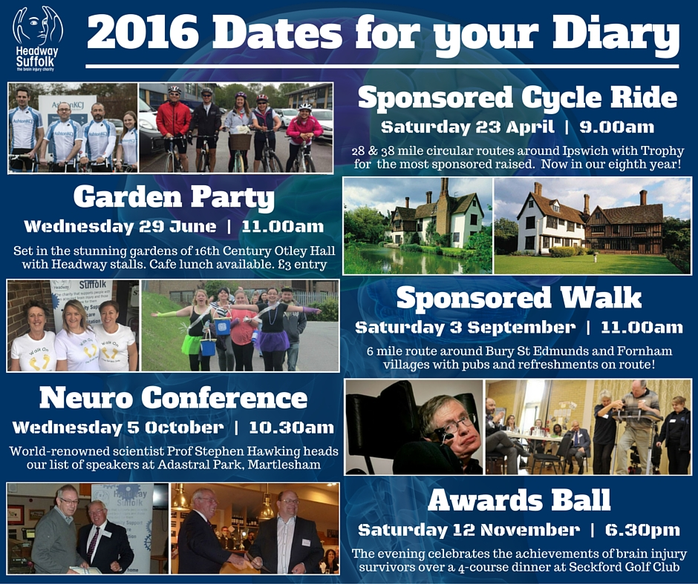

2016 promises to be another bumper year of service developments, awareness events
and fundraising campaigns for brain injury charity Headway Suffolk.

Here’s the five main dates in our calendar so far:

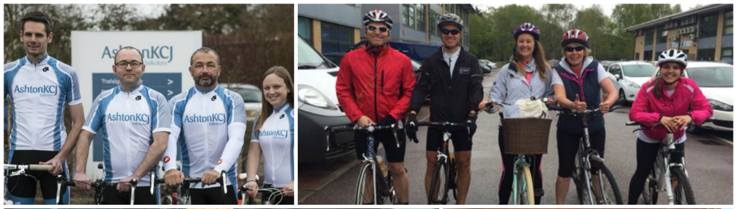

# 1 – Sponsored Cycle Ride

Our Sponsored Cycle Ride on Saturday 23 April, now in its eighth year, has already seen up to 50 people register their intent to take part, including former Ipswich Town footballer Simon Milton and a Headway team!
The circular route repeats last year's course with either 28 or 38 miles available around the Ipswich area, including seaside resort Felixstowe, which starts (and finishes) at our hub on Ransomes Europark at 9.00am.
The Cycle Ride has raised over £30,000 since the inaugural year in 2009, and once again companies will be competing for the Headway Trophy that is presented to the team that raises the most sponsorship.

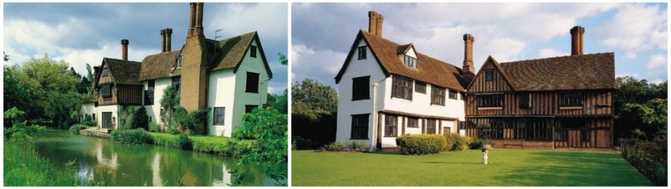

# 2 – Garden Party

Join us on a (hopefully) sunny day on Wednesday 29 June for a Garden Party in the stunning 10-acre gardens of 16th Century Otley Hall near Ipswich from 11.00am to 5.00pm.
There will be Headway stalls and sideshows with the garden cafe available for lunch. The gardens will also be open to the public and there is a £3 entry charge by the Hall.

We hope as many clients, families and carers can come along as possible, as well as friends and supporters of Headway, to make it a memorable and fun day!

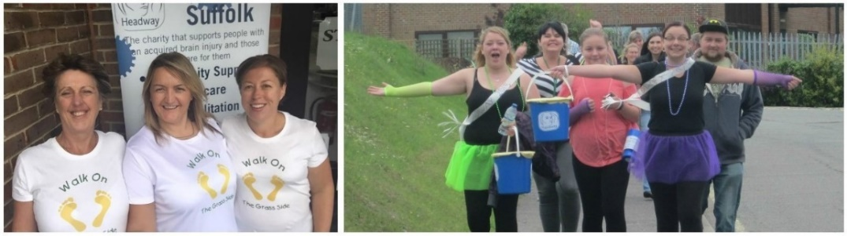

# 3 – Sponsored Walk

Our Sponsored Walk returns for a second year on Saturday 3 September at 11.00am after a successful inaugural event that saw 60 participants and £3,000 raised.
The route is expected to repeat last year's six mile course, with some possible alterations, through Bury St Edmunds and neighbouring villages, and again have participating pubs providing refreshments.
We plan to further expand on 2015's "family fun" theme - with dogs allowed and fancy dress for added entertainment!

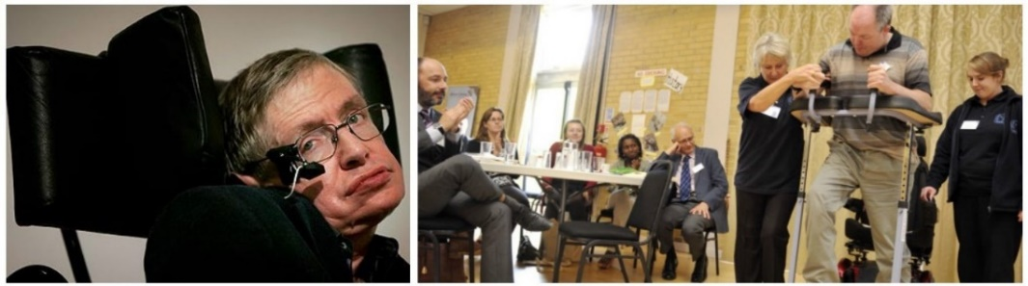

# 4 – Neuro Conference

An incredible 800 people are attending our second Neuro Conference on Wednesday 5 October at two venues - Adastral Park in Martlesham and Conference Centre in Kesgrave.
An illustrious line up of guest speakers include world-famous scientist Professor Stephen Hawking, Prof John Pickard (director of brain imaging at Addenbrooke's), Dr Trevor Powell (author of head injury publications) and Dr MR Chowdhury (stroke consultant at Ipswich Hospital).

Delegates will also hear from Suffolk County Council's Cabinet Member for Adult Care, head injury lawyers Irwin Mitchell and Headway Suffolk. Last year's Conference attained coverage across some of the UK's biggest newspapers, and this year is another not to be missed!

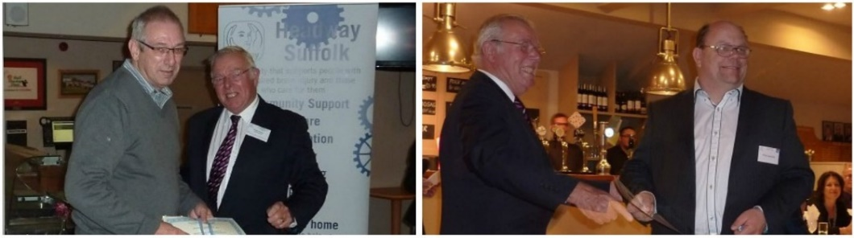

# 5 - Awards Ball

An evening of celebrating the achievements of brain injury survivors, volunteers and family carers takes place at our Awards Ball on Saturday 12 November.
Hosted at Seckford Golf Club, near Woodbridge, delegates will enjoy a delightful four-course dinner and hear inspirational stories of triumph over adversity from those who have made great strides following a brain injury.
After last year's inaugural Ball, award-winner Martin told the media: "I'm elated - to get the award is like a stepping stone achievement back into the real world." Don't miss out on hearing similar powerful stories like Martin's this year.

JOIN US

Website: www.headwaysuffolk.org.uk/events for further details

Enquire by contacting Helen on 01473 712225 or email - info@headwaysuffolk.org.uk

