Parish of Stanstead

Agenda
for an extraordinary meeting of the Parish Council

to be held on

Thursday, 12th March, 2015

at

Stanstead Village Community Centre

Members of the public and representatives of press are cordially invited to attend this meeting

01.03.15 Chairman’s welcome and apologies for absence.

02.03.15 Application No: B/15/00158/FUL
Location: Land east of 5 Blooms Hall Lane, Stanstead.
Proposal: Erection of a single-storey dwelling and garage.

03.03.15 Date of next full meeting: Thursday, 26th March, 2015

This extraordinary meeting of Stanstead Parish Council is called by its Chairman, Cllr Jean Boyes
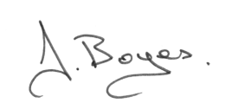

Enquiries|:
Yvonne Penman
Clerk to Stanstead Parish Council
Tel: 01787 282708
email: stansteadpc@gmail.com

